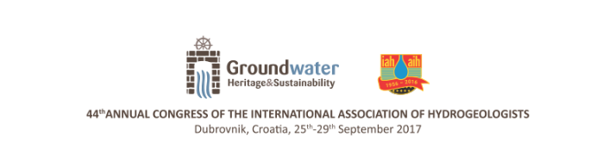
Rapid screening for pathogens
in drinking water: preliminary results
from national scale surveys in Malawi

Ward, Jade^{1,2}, Lapworth, Dan¹, Pedley, Steve², Read, Dan¹, Gwengweya, Gloria³

¹British Geological Survey, Wallingford, United Kingdom
²University of Surrey, Guildford, United Kingdom
³University of Malawi, Chancellor College, Zomba, Malawi
Lead author e-mail address: jadew@bgs.ac.uk

KEY WORDS - pathogens, rapid screening, drinking water quality, Malawi

ABSTRACT
Drinking water supplies contaminated with bacteria and viruses cause diarrheal diseases, which kill 1.8 million people a year. Sustainable Development Goal 6 highlights the need to address this issue. Currently, pathogen presence is commonly assessed by culturing thermotolerant coliforms (TTCs) as surrogate indicator organisms, however, this is an intensive and time-consuming laboratory process. Early studies have shown that the use of tryptophan-like fluorescence (TLF) as a real-time indicator of thermotolerant coliforms in the field is promising, through comparison with established laboratory culturing methods.

This study investigates the water quality of drinking water supplies in rural Malawi, Sub-Saharan Africa, at a national scale, employing both TLF and TTC culturing methods. A rigorous hierarchical approach to the sampling (a two stage stratified randomised design) was undertaken, to ensure a representative data set was collected. A total of 183 water sources across five districts in the dry season were sampled. In addition, a sub-set of sources were re-visited in the wet season. Results from an assessment of the variability in water quality from key sources (hand pumped boreholes and shallow wells), seasonal effects of rainfall and associated health risks will be presented, including a comparison of the TLF and TTC culturing methods alongside supporting hydrogeochemical data.

